**Implementing Web Application**

|  |  |
| --- | --- |
| Team ID | PNT2022TMID29529 |
| Project Name | Inventory Management System for Retailers |

# TASK

* **Create UI to interact with application**
  + Registration Page
  + Login Page
  + Display items in the Dashboard
  + Adding items
  + Test it
* **Create IBM DB2 and connect with Python**

# Create UI to interact with application

Registration Page

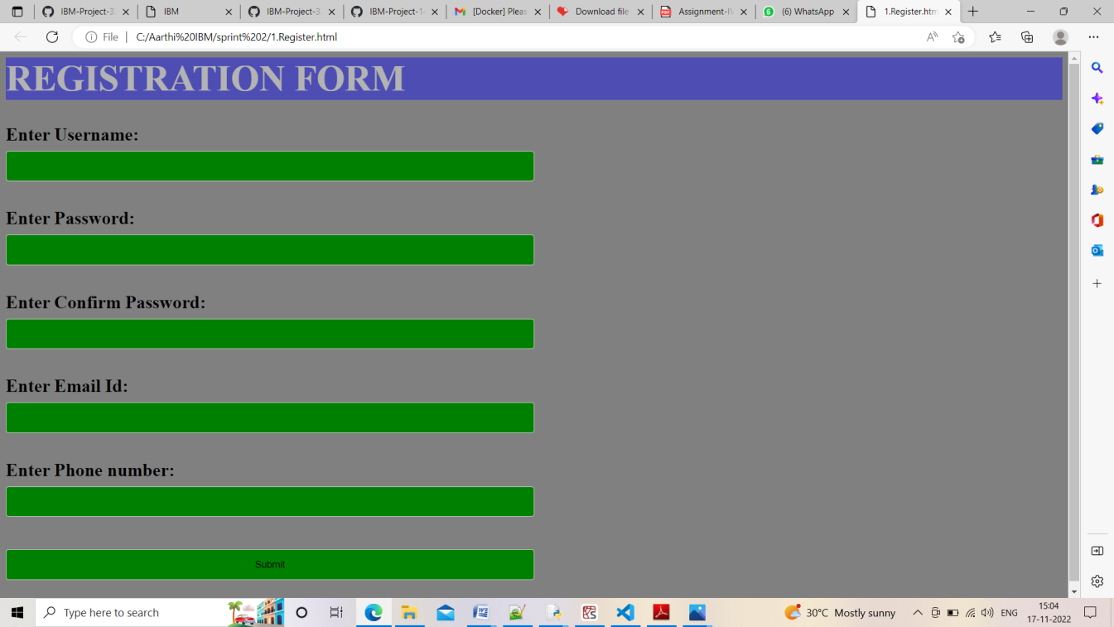

Login Page

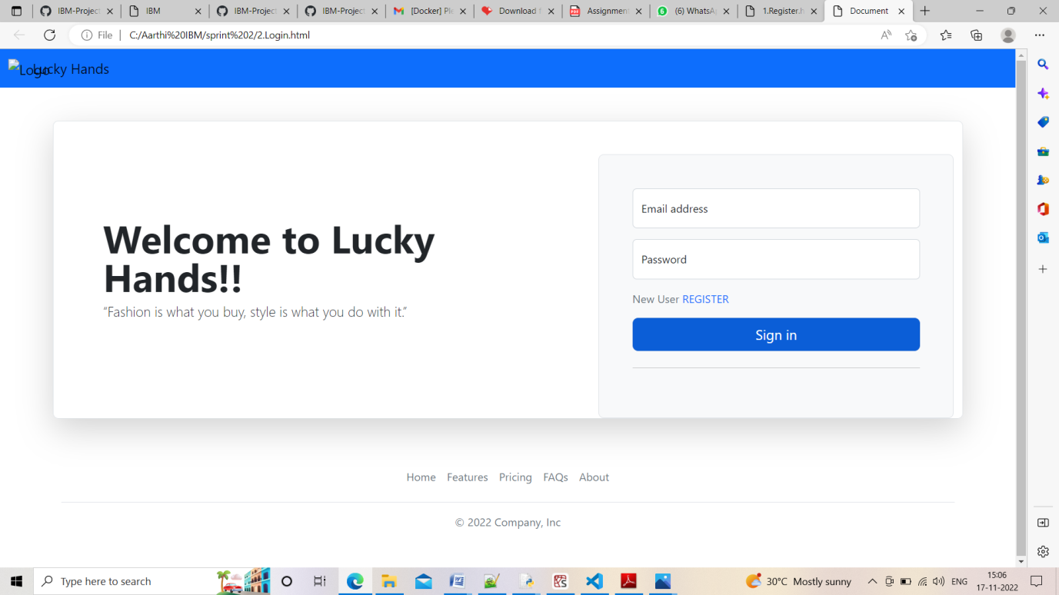

Display items in the Dashboard

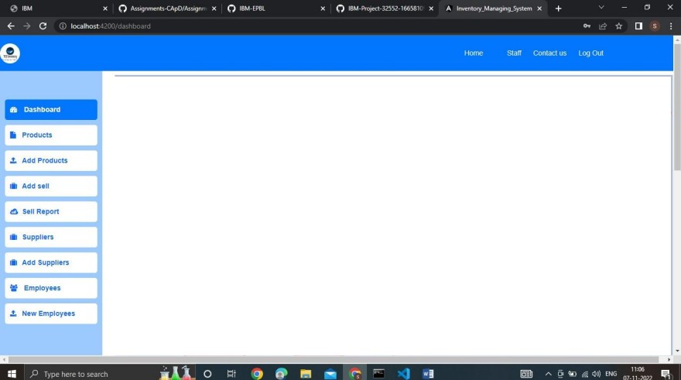

Adding items

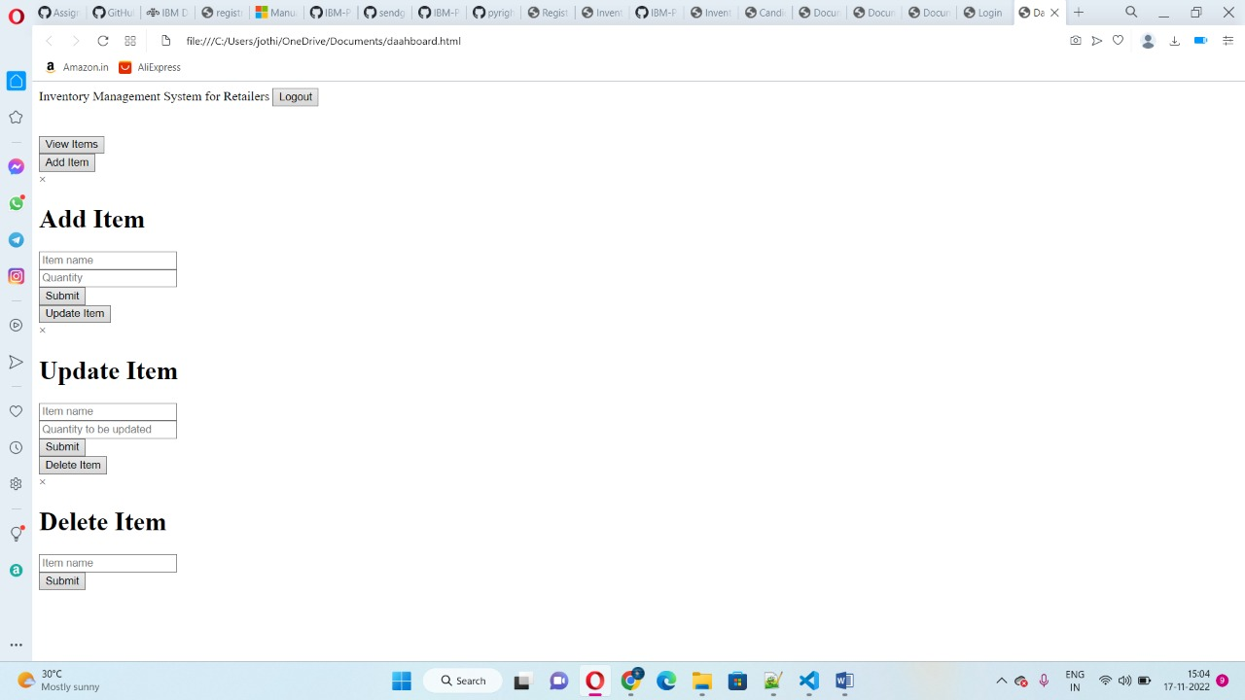

Test it

